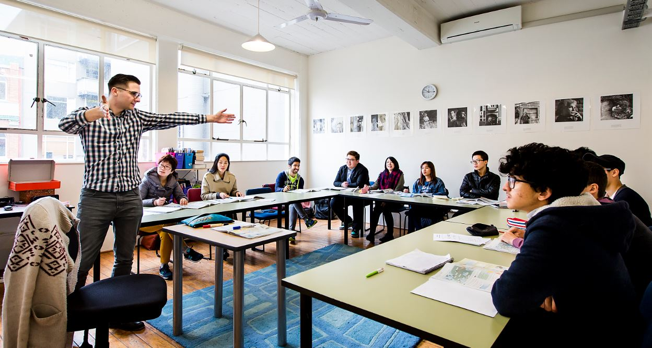

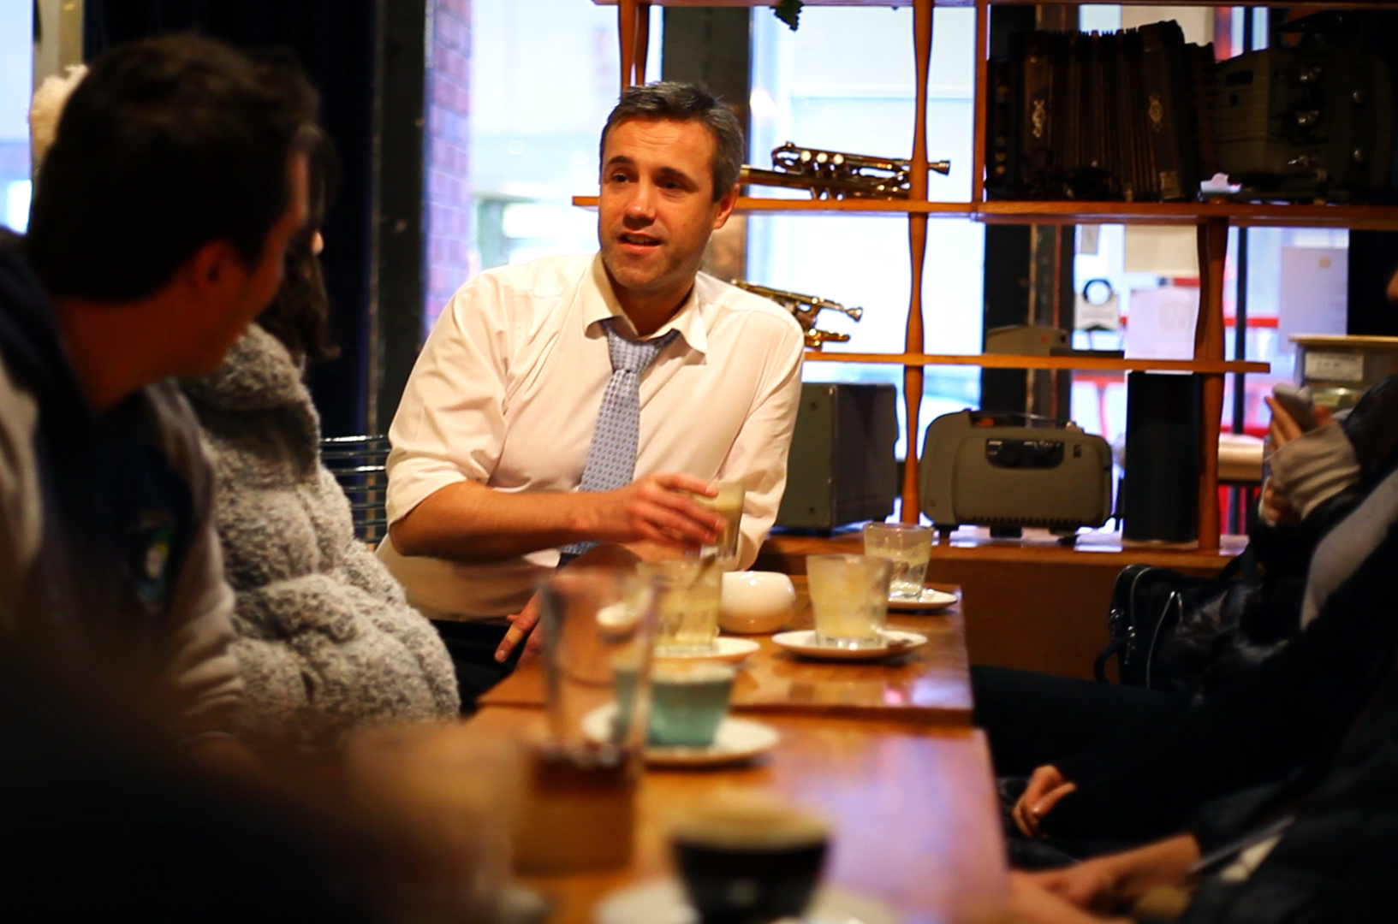

Student
Handbook

Name:

Updated 27 May 2019

Contents

Welcome 4
Wellington Staff 4
School details 5
Emergency Numbers 5
Doctors 5
Sexual Health Issues 6
Emergency Procedures for Students 6
Accident 7
Fire 7
Earthquake 8
Serious Illness….……………….…………………………………………………………………………………………………………………….. 7
Legal Information and Advice for Students 8
New Zealand Law 8
Rules and Regulations for The Campbell Institute 10
1. Validity of Documentation 10
2. Attendance 10
3. Holidays 10
4. Drug and Alcohol Use 10
5. Code of Conduct 11
6. Insurance 11
7. Visa Requirements 11
8. Textbooks 11
9. Disciplinary Process 13
10. Complaints Procedures – Wellington & Auckland 13
Code of Practice 14
Withdrawal and Refund Policies and Procedures 15
Homestay in New Zealand 16
Questions To Ask Your Homestay Host 19

More information for students is on The Campbell Institute website – www.campbell.ac.nz

Welcome
Welcome to Wellington and The Campbell Institute. We are delighted that you have chosen to study with us and we hope that you enjoy your time here.
Please do not hesitate to talk to any of the staff if you have any questions or concerns.
Good luck with your English Study!

Wellington Staff

Administration
Helen King – Campus Manager
Ashley Oswin – Administration and Student Support Officer
Carolina Coimbra Simpson – Student Support and Homestay Officer
Raewin Ormond – Demi Au Pair Programme Manager
Sabrina van Saarloos – Activities Co-ordinator
Daniela Silva – Regional Homestay Coordinator (Host Families NZ)

Academic
Jamie Cruse – National Academic Director
Guy Walker – Director of Studies

School information
The Campbell Institute
Level 4, West Wing
Wellington Railway Station
2 Bunny Street, Pipitea 6011
Mail address:
The Campbell Institute
Po Box 670
Wellington

Ph: +64 4 803 3434 NZ = 64 Wellington = 04
Email: wellington@campbell.ac.nz

NZ Emergency Number
111 – Fire service, Police, Ambulance
The police in New Zealand are safe and trustworthy. In an emergency, please call them.

The Campbell Institute 24 Hour Emergency Number

021 023 16965 (within New Zealand)
+64 21 023 16965 (outside New Zealand)
Please call this number to inform The Campbell Institute of your emergency. If you need the fire service, police or ambulance, ALWAYS call 111 first.

Wellington Police – non emergencies
Ph: (04) 381 2000
When you call the police you may be able to ask to speak to someone in your native language. Please ask when you call.

Doctors
In New Zealand, people only go to the hospital in an emergency.
If you are feeling unwell, but it is not an emergency, we recommend the following clinics below. The Student Services Team can help you to make an appointment.

City Medical Centre (www.citymedical.co.nz)
Phone: 471 2161
Address: Level 2, 190 Lambton Quay
You will need to make an appointment to see a doctor at this clinic and they are closed on the weekend.
If you cannot wait for an appointment you can go to:

Accident & Urgent Medical Centre - 17 Adelaide Road, Newtown Ph: (04) 384 4944
They are open 24 hours, 7 days per week.

You will need to pay for your visit to the doctor after the appointment. Please keep your receipt as your insurance company will pay the money back to you. If you have purchased Uni-care insurance from The Campbell Institute, the Student Services Team can assist you in making a claim.

Sexual Health Issues
The Campbell Institute has information in the Learning Hub that you can read - about sexual health, including contraception, pregnancy, and Sexually Transmitted Diseases. You can also contact Family Planning for free and confidential advice and help:

Family Planning Clinic – Margaret Sparrow  6th Floor  35 - 37 Victoria Street  Wellington  Phone: (04) 499 1992 | Open Hours:  Monday: 8:30 am – 5pm  Tuesday: 8:30 am - 5 pm  Wednesday: 8:30 am – 5 pm  Thursday: 8:30 am - 6:30 pm  Friday: 8:30 am - 5pm  Saturday: 8:30 am - 12:00 pm

Mental Health Issues
Your mental health is important. If you are felling very sad or depressed, please let one of our Student Services Team know and we can refer you to a professional counsellor. You can also use any of the following services:
Need to talk? Free call or text 1737 any time to talk to a trained counsellor.
To talk to a trained counsellor 24/7 call the Depression helpline – 0800 111 757.
To get help from a registered nurse 24/7 call Healthline – 0800 611 116.
Youthline – 0800 376 633, free text 234 or email talk@youthline.co.nz or online chat.
If you need very urgent help, please call 111 immediately.

Emergency Procedures for Students
In any unforeseen event or emergency where The Campbell Institute is closed, please monitor The Campbell Institute Facebook page for live updates: www.facebook.com/TheCampbellInstitute

Accident
If you or somebody you know has a serious accident, you should do the following:
1. Call emergency services: 111. Tell them your location.
2. Contact The Campbell Institute on the emergency phone (021 023 16965)
3. Contact your parents. If you cannot contact your parents, The Campbell Institute will do this for you.

Fire
At School:
- Leave the building as quickly and as calmly as possible. DO NOT try to take your bag or other things with you.
- Meet at the large Assembly Point directly in front of the Railway Station on the grass. There will be regular practice evacuation drills to show students exactly where they need to go.
- Check your name with your teacher.
- DO NOT GO HOME until your name has been checked by your teacher.

At home:
- If it is safe, call the Fire Service – dial 111. The first question you will need to answer is YOUR LOCATION.
- Make sure that other people in the house are awake, and check to see if they need help.
- Leave the house as quickly and as calmly as possible. DO NOT try to take things with you.
- Wait outside until emergency services arrive.

Earthquake

Inside:
- Move no more than a few steps, Drop, Cover and Hold. Drop to the floor, seek cover under furniture or close to a wall and protect your neck and head.
- Stay indoors till the shaking stops and you are sure it is safe to exit.
- If you are at School, the earthquake assembly point is directly infront of the Railway Station on the grass. There will be regular practice evacuation drills to show students exactly where they need to go.
- Check your name with your teacher.
- DO NOT GO HOME until your name has been checked by your teacher.

Outside:
- If possible, move away from buildings, trees, streetlights, and power lines, then Drop, Cover and Hold.
- If you are at the beach or near the coast, drop cover and hold, then when the shaking stops, move to higher ground immediately in case a tsunami follows the quake.

Crime or Violence
- In a violent situation, the most important thing is to remove yourself from danger as quickly as possible.
- Call the Police – call 111
- Contact The Campbell Institute on the emergency phone (021 023 16965 – available 24 hours, 7 days)

Serious Illness
- In an emergency, call 111 for an ambulance.
- Contact The Campbell Institute (021 023 16965) as soon as possible.
- Contact your parents or family. If you cannot contact your family, The Campbell Institute will do this for you.
- If you are not sure if your illness is serious and you cannot get to a doctor, you can call Health Line for FREE ADVICE on 0800 611 116. This service is available 24 hours, 7 days a week.
- If you or your friend is sick and you don’t know what to do, you should contact The Campbell Institute immediately.
- If you need to see a doctor after normal work hours or during the weekend, but if it is not an emergency you should go to:
After Hours Accident and Emergency Centre
17 Adelaide Road
Newtown

Legal Information and Advice for Students
If you have any questions or need help, please contact the Student Services Team. If you would like information on cultural or community support (including contact details for government agencies and embassies in Wellington), the Student Services Team can help you to contact them.

New Zealand Law
Students must abide by the laws of New Zealand. If a student gets involved in any criminal activity, enrolment at The Campbell Institute will be terminated immediately, and the New Zealand Immigration Service will be notified to cancel the student visa if applicable.

Alcohol and drugs
- It is illegal to purchase or use drugs in New Zealand.
- If you are under 18 years old, it is illegal to buy or drink alcohol.
- If you are over 18 you must have a photo ID (passport or driver’s license) to purchase alcohol.
- It is illegal to buy alcohol for somebody who is under 18.

Cigarettes and Smoking
- You are not allowed to smoke inside or directly outside of The Campbell Institute in the entrance. If you want to smoke, you must go to the Smoking area outside of the East Wing of the Railway Station.
- If you are under 18 years old, it is illegal to buy cigarettes.
- If you are over 18 years old, you must have photo ID (passport or driver’s license) to purchase cigarettes.
- Smoking is not allowed in most indoor places, including public buildings, restaurants, bars, and offices.

Age of Consent
In New Zealand it is illegal to have sex with anyone under the age of sixteen.

Driving and Car Insurance
- It is illegal to drive without a correct driver’s license. If you have an overseas driver’s license, you must carry an official translation, or after 1 year, apply for a New Zealand driver’s license.
- To learn to drive you must be at least 16 years old.
- Car insurance is not compulsory by law in NZ; however, it is STRONGLY recommended that students have car insurance if they drive a car. Only drive a friend’s car if you have car insurance.
- If you are involved in an accident, and you have no insurance, you may need to pay for all the damage.

Contracts
- In many situations in NZ, you are required to sign a contract. This includes when you rent a house or bedroom (a tenancy agreement), or when you establish an account with a company or bank. If you are asked to sign a contract, you should always ask someone to check it for you first. If there is anything in the contract you do not understand, you should check it first. The Student Services Team are happy to help you to check a contract before you sign it.
- If you want to rent accommodation, you are mostly required to pay a bond. This money must be deposited with Tenancy Services and not to other tenants. Renting in New Zealand is different from many other countries, so it is a good idea to talk with the Student Services Team if you are unsure. You can also find out more information about renting in New Zealand at: www.cab.org.nz
- If you sign a contract you must follow the conditions. New Zealand legal assistance can be very expensive, but in most situations, a problem can be solved through negotiation before a lawyer is necessary.
Working in New Zealand
- Visa permitting, students may be able to work while studying. Most students on a student visa are allowed to work up to 20 hours per week.
- It is important that students are aware of their work rights before signing a work contract. The minimum wage in New Zealand is $16.50 per hour – this means employers must pay this or more by law.
- Students can speak to a teacher more about working in New Zealand in the weekly Job Hunter workshop.
- The Student Services Team can also help with any questions related to working in New Zealand, and can read over contracts. Citizens Advice Bureau (located in the same building as the library) can also help you with this.

Rules and Regulations for The Campbell Institute

1. Validity of Documentation
Enrolment is conditional on the validity of documentation supplied by applicants at time of application/enrolment. If at any time before or after enrolment, documentation is found to be invalid, enrolment will be cancelled, and the student will not receive a refund.

2. Attendance
Students are required to attend ALL programmed tuition hours. Failure to meet attendance requirements may result in expulsion from The Campbell Institute and cancellation of student visa. Immigration NZ expects that all students who are studying on a student visa maintain a 90% attendance rate.
Students are required to arrive for class on time. If a student is more than 10 minutes late to class three times, they will be marked absent for one day.
Absence from class may be excused for the following:
- Medical reasons (if a medical certificate is presented) following a visit to a GP/hospital.
- Bereavement
- Other major trauma
At the end of their course students will receive a Certificate of Course Completion. This is subject to the students’ attendance rate, and students with an attendance lower than 90% may not receive a certificate.

Lateness
You are expected to arrive on time for all of your classes. If possible, please try to be at school five or ten minutes before the start of your class.
Why you need to be on time:
- Being late makes it difficult for your teacher to teach the class effectively and has a negative impact on your learning as well as the learning of others.
- Regular lateness will have a negative impact on your attendance rate and may lead to attendance warnings and further action.

IMPORTANT:
- All students who arrive late must report to reception before going to class.
- If you arrive up to 10 minutes late, you will be given an orange warning slip to present to your teacher. You are expected to explain to your teacher your reason for being late. Your teacher will mark you as “present” (P) and you will be able to join the class.
- If you arrive more than 10 minutes late, you must sign the Late Book at reception and you will be given a red slip to present to your teacher. You are expected to explain to your teacher your reason for being late. Your teacher will then tell you when you may join the class. Your teacher will mark you as “late” (L).

3. Holidays
Students may be able to take a 1 week holiday for every 12 weeks of tuition, if their attendance rate is over 90%. Students who want to take a holiday during their course must apply for a holiday by completing a Holiday Request form (from reception). No flights should be booked until the holiday has been approved by the Student Services Team.

4. Drugs and Alcohol Use

Intoxication
If a student attends class under the influence of alcohol or drugs, tuition will be immediately suspended, and the student may be expelled, in which case the New Zealand Immigration Service will be notified to cancel the student’s visa if applicable.

5. Code of Conduct
The Campbell Institute expects high standards of professionalism and behaviour from both staff and students. The Campbell Institute has a culture of inclusion and expects students to respect all other students and staff of all cultures, religions, ethnicities, genders, ages, and backgrounds. Bullying or harassment of any kind will not be tolerated.

Suspension and Expulsion

Should either a staff member or student be found to disrespect either other members of the faculty, or students, or be found to deliberately break the terms of the Code of conduct, this would be considered a serious breach of the Code. Disciplinary measures are contained in staff employment contracts. For students who wilfully disregard the Code of Conduct, the following steps may be taken, during which a student has the right of reply, and advocacy, at any, or all, stages:
- The student receives a verbal warning, and an opportunity to modify their behaviour within 5 working days.
- If the student does not modify their behaviour, they receive a written warning, outlining the breaches of the Code of Conduct and a further 5 working days to consider and modify their behaviour.
- If there are no changes to their behaviour, the student is formally suspended from class. An appointment is made by the management team to discuss with the issue with the student, (and an advocate), and a plan of remedial action, or referral to external agency, such as a counsellor, is offered.
- If the student’s behaviour continues to be in breach of the Code of Conduct, their enrolment is terminated, and they are expelled.

Smoking
The Campbell Institute has a No Smoking policy indoors and outside in the entrance of The Campbell Institute.
Noise
The Campbell Institute undertakes to respect the requirements of its neighbours for peace and quiet. Students and staff must always act responsibly.
Use of Computers
Internet access is provided to students free of charge. Please do not download games, movies or music.
Wireless connection is available but students must comply with specific policies developed from time to time in relation to use of the computers at The Campbell Institute, including access to the Internet.

Recycling
At The Campbell Institute, we believe recycling is very important. All rubbish bins are labelled – please make sure you put the correct type of rubbish in each bin. If you are unsure, please ask reception.

6. Insurance
As part of the enrolment process, each student is required by law to purchase medical and travel insurance. This must provide cover from the time the student leaves their home country until the end of their studies in New Zealand. The Campbell Institute will keep a record of each student's policy and the type of cover provided.

Insurance may be purchased directly, or via the Institute at time of enrolment. The Campbell Institute uses Uni-Care Student Insurance and the Student Services team will assist students to make an insurance claim if they have Uni-Care insurance.

Please note that if you have purchased your own insurance you must provide a certificate of cover at the time of enrolment.

If you purchase an insurance policy that does not meet the Code standards, you may be required to purchase another appropriate insurance policy before you can enrol.
Students acknowledge that The Campbell Institute may, from time to time, amend or add to these rules in the interest of The Campbell Institute and the student, and the student is bound by such amendments, once appropriate notification has been made.

7. Visa Requirements
It is the student’s responsibility to ensure that they are on a valid visa while studying at The Campbell Institute. Student visa holders must study fulltime. Some student visa holders and can work 20 hours a week only. If you are unsure of your visa requirements, please check with the Student Services Team.

8. Textbooks
All students are invoiced $100 including GST to cover a “materials fee”. This is in the original invoice.
This is non-refundable. There is no exception to this.
The textbook provided to the student may or may not be new, but will be in good condition when the student receives the book. This can be exchanged for another textbook if/when the student moves to a new class level. Books can only be exchanged if they are returned in good condition – i.e. not written in or damaged. A student can elect to keep their original book and pay another $60.00 for another new textbook at their next class level.
When a student finishes their study with us they are entitled to take whatever book they hold with them when they leave. If a student loses or returns a book in a damaged condition, they will be required to pay a further $95 for another textbook.

9. Disciplinary Process
Non-Compliance with the Rules and Regulations and other conditions as contained in the Conditions of Enrolment by the student will result in the following:
- The student will receive a first verbal warning.
- If there is no immediate satisfactory improvement, the student will receive a first written warning.
- If there is still no immediate improvement, the student will receive a second and final written warning.
- Following the issue of the Final Warning, if no improvement is made the student’s enrolment will be terminated, and Immigration NZ may be notified, if applicable. The student will not be entitled to a refund.
- In the event of serious misconduct, The Institute reserves the right to immediately terminate a student’s enrolment.
- Termination of Enrolment may be carried out for reasons including, but not limited to:
- Significant non-attendance
- Behavioural misconduct
- Plagiarism or cheating
- Substance abuse

10. Complaints Procedures – Wellington & Auckland
  - All complaints should in the first instance be addressed through internal complaints procedures as outlined below. All complaints procedures will be treated confidentially.
  - A student with a complaint that concerns a particular staff member should in the first instance discuss the issue with that staff member if possible. An appointment should be made with the staff member to discuss the issue at an appropriate time. Staff should ensure that they document any conversations in sight of the student and store these confidentially in the student’s file.
  - If the student is unable to, or feels uncomfortable addressing the staff member concerned, the student may approach Managers in Wellington and Auckland. If the student prefers, they may approach the Senior Management in Wellington or Auckland either by phone, email, and letter or by making an appointment.
  - If the complaint is concerned about sexual harassment, the student should approach any member of staff that the student feels comfortable approaching, or the external counsellor directly. Members of staff who are untrained are required to refer the complaint to someone who is trained in the area of sexual harassment.
  - In all cases, the student may make an oral complaint initially. If the member of staff approached feels that the complaint is of a particularly serious nature, the student will be advised to submit the complaint in written form to the General Manager. In the absence of the General Manager, written complaints may be addressed to the Director of Studies. If required, the student may request the aid of a translator.
  - Oral complaints will be dealt with immediately or as soon as practicable. Written complaints will normally be dealt with within two weeks of submission, or sooner depending on the nature of the complaint.
  - If a student feels that a complaint has not been satisfactorily dealt with by the Institute, he or she may submit their complaint in writing to an external authority, such as:

New Zealand Qualifications Authority (NZQA)
Email helpdesk@nzqa.govt.nz
Telephone +64 4 802 3000
Fax +64 4 802 3112
Postal address PO Box 160, Wellington, New Zealand
Our school is a member of English New Zealand. If you have a complaint we haven’t been able to resolve, you may wish to write to our professional body and ask for assistance.

English New Zealand
Email admin@englishnewzealand.co.nz
Telephone +64 3 386 1222
Postal address PO Box 35283, Christchurch 8640

Code of Practice for the Pastoral Care of International Students

Introduction
When students from other countries come to study in New Zealand, it is important that those students are well informed, safe, and properly cared for.
New Zealand educational providers have an important responsibility for international students' welfare.

What is the Code?
The Code is a document that provides a framework for service delivery by educational providers and their agents to international students. The Code sets out the minimum standards of advice and care that are expected of educational providers with respect to international students. The Code applies to pastoral care and provision of information only, and not to academic standards.

Who does the Code apply to?
The Code applies to all education providers in New Zealand with International Students enrolled. The Code is mandatory to these providers and must be signed by them.

What is an "International Student"?
An "International Student" is defined as a student studying in New Zealand who is not a New Zealand citizen, Permanent Resident or Resident.

How can I get a copy of the Code?
You can request a copy of the Code from your New Zealand education provider. The Code is also available online from http://www.education.govt.nz/ministry-of-education/legislation/regulations-to-support-international-students/

How do I know if an education provider has signed the Code?
The New Zealand Ministry of Education maintains a register of all signatories to the Code. This is available online from www.education.govt.nz If the education provider that you are seeking to enrol with is not a signatory to the Code, you will be granted a permit from the New Zealand Immigration Service and you will not be able to study at that institution.

What do I do if something goes wrong?
If you have concerns about your treatment by your education provider or by an agent of the provider, the first thing you must do is contact the Principal, the International Student Director, or another person who has been identified to you as someone that you can approach about complaints at your institution. The Code requires all institutions to have fair and equitable internal grievance procedures for students and you need to go through these internal processes before you can take the complaint any further.
If your concerns are not resolved by the internal grievance procedures, you can contact NZQA is a government organisation. They can provide an independent assessment of your complaint and will either investigate your concerns or advise you what you can do next.

You can submit your complaint query on the NZQA website, or send an email to qadrisk@nzqa.govt.nz
If you need more information on the complaints process, contact NZQA on 0800 697 296. Another useful website is to help you with this process is: http://www.istudent.org.nz/

Summary of the Code of Practice for the Pastoral Care of International Students
The Code sets standards for education providers to ensure that:
- High professional standards are maintained
- The recruitment of international students is undertaken in an ethical and responsible manner
- Information supplied to international students is comprehensive, accurate, and up-to-date
- Students are provided with information prior to entering into any commitments
- Contractual dealings with international students are conducted in an ethical and responsible manner
- The particular needs of international students are recognised
- International students are in safe accommodation
- All providers have fair and equitable internal procedures for the resolution of international student grievances
Full details of what is covered can be found in the Code itself.

Withdrawal and Refund Policies and Procedures

1. Withdrawal and Refund Regulations
Please note that all refunds will be in New Zealand dollars and will not take into account any fluctuations in currency exchange rate between the time of enrolment and the time of refund.

1.1 Withdrawals and cancellations
Withdrawal from a programme is when a student withdraws before or after commencing studies:
Programme | Full Refund of all fees | School/College to retain 25% of tuition and course related fees paid | No Refund
For programmes 3 months or longer in duration | Notice received by the School/College 21 working days or more prior to the course commencement | Notice received by the School/College up to the end of the 10th working day following course commencement | Notice received by the School/College on or from the 11th working day following course commencement
For programmes less than 3 months in duration | Notice received by the School/College 6 working days or more prior to the course commencement | Notice received by the School/College up to the end of the 5th working day following course commencement | Notice received by the School/College on or from the 6th working day following course commencement
Notes:
- Commencement of the course is inclusive of orientation days, at which attendance is required.
- The Education Act 1989 provides for minimum refund thresholds in certain circumstances. As at December 2018, the refunds payable according to the table above fell within the thresholds determined by the Education Act 1989. If the minimum refund thresholds in the Education Act 1989 are adjusted downwards, the table above will be deemed to be adjusted downwards in order that the School/College’s refund policy continues to comply with the relevant thresholds.
Cancellation of Private Tuition class by a student:
If The Campbell Institute is informed of a class cancellation (for any reason) 24 hours prior to scheduled class time, the student will not be charged for the cancelled class and is able to reschedule. However, if the student does not inform The Campbell Institute, there is no entitlement for a refund.

Cancellation due to declined visa:
Where an Offer of Place was made and the visa application declined by INZ, tuition fees are refundable less any costs incurred by the School/ College prior to the School/College becoming aware of the visa not being granted.

1.2 Expulsions
In the case of a student’s expulsion from The Campbell Institute, there will be no refund of tuition fees.

1.3 Homestay Fees and Accommodation Management Fees
Homestay fees are fully refundable provided 2 weeks’ notice is given to homestay provider, or 2 week of homestay fees is forfeited. Accommodation Placement fees are non-refundable.

2. Withdrawal and Refund Procedures
In order to claim a refund, an Application for a Refund of Tuition Fees must be made in writing to the Institute. If the application is received after the standard time frame for withdrawal from the course, the application must include the reason for withdrawal or cancellation. The application will be considered by the ACG Registrar.
Withdrawal and Refund forms are made available to students on request.
The Institute will consider the following factors when awarding a refund:
- The circumstances and reasons for withdrawal.
- The costs already incurred by the school, including teachers’ salaries, resources committed to the delivery of the course, and administrative costs.

Homestay in New Zealand

Welcome to New Zealand!
Living in a New Zealand home may be very different to your home country, food and family. Please remember that you are living in someone’s home. It is not a hotel so you must treat the family and the house with respect. Please read the Homestay Rules and Memorandum of Understanding carefully.

Every home is different. Below are some guidelines to help you settle in. It is important that you communicate with your homestay. If you don’t understand something they say or how to do something, please ask your homestay to explain.

Daniela Silva is the Regional Homestay Coordinator at Host Families NZ and organises all homestays for students at The Campbell Institute.

- It is important to let your homestay know where you are going and what time you will be home. Please call your homestay if you are coming home late, so they do not worry about you.
- Please give your homestay your mobile number.
- Food: The food will be different to your home country. Please be prepared to try some new food. If you do not like something you do not have to eat it, but please be polite. An example of traditional New Zealand food is:
  - Breakfast: Cereal, Toast and jam, tea or coffee
  - Lunch: Sandwiches, snacks or fruit
  - Dinner: Meat (chicken, fish or red meat) and vegetable (peas, beans, potatoes)
Your homestay will make dinner but it may be “help yourself” at breakfast time and lunch. Please ask your homestay what to do for these meals and which food you can have for snacks.
- Please tell your homestay if you have an allergy to any food items.
- If you are not coming home for dinner you must text or call you homestay 2 hours before dinner time to let them know. If you would like them to keep your dinner for you to eat when you get home please ask.
- You will be expected to make your bed and keep your room tidy. It would also be polite to also help out with some small household chores such as drying the dishes or setting the table.
- You should have a heater in your room; this must be turned off when you leave the room and when you go to bed. DO NOT HAVE IT GOING ALL NIGHT as the power usage is too high. Do not have the window open and the heater going at the same time.
- You may have an electric blanket on your bed. This must be turned off when you get into bed as if it is slept on it may cause a fire. If you are cold during the night please ask your homestay for an extra blanket. In New Zealand your homestay family may go to bed around 9.30 or 10 pm. If you wish to stay up later than this please ensure you do not make any noise.
- Please ask before borrowing anything in the house. If you break any household item you will be required to replace it.
- Showers: Most NZ houses have a water tank which heats the water once during the day. If you have a long shower you may use up a lot of hot water and the next person is forced to have a cold shower. Please restrict your shower time to 7-10 minutes.
- You will need to supply your own toiletries (shampoo, conditioner, toothpaste).
- Please ask your homestay host where to put your dirty washing. If you wish to wash your own clothes ask your homestay where to do this and how to use the machine. In NZ we hang the washing outside to dry even in winter – DO NOT HANG WET WASHING IN YOUR ROOM OR WARDROBE as this can damage the walls.
- Before asking your friends to come over please ask your homestay.
- You do not have to pay for internet access in your homestay. The school has free internet access and you are welcome to bring your laptop to school to access our network.
- Please ask when is a good time to use the house phone. You will have to pay for any international call you make and also any calls you make to a mobile phone. We recommend that you get an international calling card to make calls as this is much cheaper for you.
- NO SMOKING inside the homestay house. They might be happy for you to smoke outside so please ask your homestay what to do with your cigarette butts – do not put them on the lawn or in the garden.
- Please do not bring alcohol into the homestay without their permission and only if you are over 18 years old.
- Your homestay host is not your teacher; it can be expected that they assist you with your homework if needed, but they will not give you an “English Lesson”.
- PLEASE and THANK YOU are important words in the English language

Questions to Ask Your Homestay Host
Below are some questions that you can go through with your homestay to help you feel part of their home. You do not have to ask all of the questions.
- What do I call you? Mum, Dad, or your first name?
- What is the procedure about dirty clothes? Where do I keep them until wash days?
- Should I wash my own underwear?
- Where should I dry any clothes I wash?
- What is the procedure about ironing clothes?
- May I use the iron, washing machine, sewing machine etc.?
- Where can I keep my bathroom toilet accessories?
- When is the best time for me to use the bathroom on weekday mornings?
- When is the best time for me to have a shower a.m. or p.m.? How long may I stay in the shower?
- May I use the bathroom toiletries (shampoo, toothpaste)?
- What time are meals?
- Do you need to help before or after mealtimes?
- May I help myself to food and drink (non-alcoholic) at any time or must I ask first? - (Promise to do this in moderation if acceptable)
- What areas of the home are strictly private e.g. parents’ bedroom, study, sewing room, pantry?
- May I put pictures, posters etc. on walls in my bedroom?
- May I rearrange my bedroom?
- What are your rules about smoking?
- What time must I get up weekday mornings?
- What time must I get up on weekends and holidays?
- What time must I go to bed and turn the lights out on weekdays and weekends?
- Do I have to ask if I go out? (Exceptions by special arrangement?)
- Can I have friends to stay overnight?
- Can I invite friends around in the day? (Not opposite sex if parents not there).
- What are the rules about using the telephone including overseas calls?
- What are the rules about sending and receiving emails and using the Internet?
- May my friends phone me?
- How do I get around? E.g. is there a bus route? Do I get a bicycle? Where can I buy a bus pass?
- May I play the stereo, television, VCR etc.?
- Would you like me to phone or text if I am going to be 10, 20 or 30 minutes late?
- from school
- from any other outing
- What arrangements are there for making lunch
- on a school day
- at the weekends?
- If I have any problems, who would you like me to go to?
- Is there anything else you would like me to know?

The Campbell Institute
Wellington Campus
Level 4, West Wing
Wellington Railway Station
2 Bunny Street, Pipitea 6011

Phone: +64 4 803 3434

www.campbell.ac.nz
wellington@campbell.ac.nz

